The 5th Annual
THURSDAY, OCTOBER 26, 2017
Tier Sponsorship Package

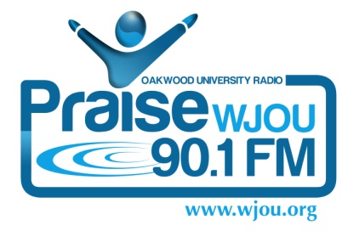

Dear Community Partner:

For 37 years WJOU 90.1 FM, licensed to Oakwood University, has continued its mission to provide radio programming to the Huntsville community that is positive, family oriented, and life changing. A major part of that mission is our commitment to community service. Our Annual Community Health Fair is a result of that commitment.

For the past four years, Praise 90.1FM WJOU in partnership with Good Samaritan Hospice has sponsored this annual health and wellness event. Once again on Thursday, October 26 at our Fifth Annual Community Health Fair, we will provide free health screenings…from blood pressure to BMI, and we expect over 500 participants from the Huntsville and Oakwood communities. Proceeds from this community event will fund five $1,000 scholarships to benefit students at Oakwood University. The scholarships will be awarded during the health fair. To date, we have awarded over $10,000 in scholarships!

We will also present our 2017 Community Award to two individuals committed to health and wellness in the Huntsville community. Last year recipients were Cathy Miller, Community Impact Director
United Way of Madison County and Artis & Edna Sidney, co-owners of Garden Cove Produce.
Past award recipients include the Honorable Thomas “Tommy” Battle, Jr. Mayor of Huntsville, Donna Green-Goodman, health educator, author and television personality and Dr. Leslie Pollard, President of Oakwood University.

Our 5th Annual Community Health Fair will be held on Thursday, October 26, 2017 from 11am to 3pm in the Millet Activity Center on the campus of Oakwood University. Thank you for your time and consideration. You have an opportunity to join us as a tier sponsor. You will find more information in this package.

Please let me know if you have questions or need additional information. To learn more about our Annual Health Fair, please visit our website at www.wjou.org. Come and join us as we “empower the community to live healthy.”

In Partnership,

Reggie Hicks
General Manager
Praise WJOU 90.1FM

7000 Adventist Blvd, NW Huntsville, AL 35896 phone (256) 726-7418 fax (256) 837-7918

Station Highlights

WJOU-FM is a broadcast service of Oakwood University celebrating 37 years of service to the Huntsville community.

WJOU-FM broadcasts at 25,000 watts with a coverage area of 30 miles.

WJOU-FM has over 12,000 listeners tuning in each week.

WJOU-FM has over 10,000 on-line listeners each month via ChristianNet.org, the station’s on-line streaming service.

WJOU-FM is a full service radio station that operates 24-hours a day and 365 days a year.

WJOU-FM provides life-changing programs through praise and gospel, community affairs, and spoken word programming.

WJOU-FM airs a number of local programs including the award winning, 2nd Chance program with Kenny Anderson. This year marks the 25th anniversary of this groundbreaking community affairs program.

WJOU-FM is highly committed to community service and partners with many charitable organizations. Each year, WJOU hosts a Community Health Fair that provides scholarships to students attending Oakwood University.

WJOU-FM provides students of Oakwood University with valuable hands on training and professional guidance as part of our mission to educate and train the next generation of broadcast professionals.

Benefits of Sponsorship

Praise WJOU 90.1FM–delivers your message with greater efficiency and frequency. Your message will be heard consistently and will prompt actionable activity sooner by our dedicated listeners.

Increase your market share. Establish brand identity with the Praise WJOU 90.1FM listening base that consists of business professionals, educators, loyal consumers, community leaders, and administrators.

Ensure that your messaging is heard. Underwriting on Praise WJOU 90.1FM places you and your products and services in a unique position by clearly separating your brand from the clutter on commercial radio. Praise WJOU 90.1FM listeners hear your messaging as content–not as inconspicuous information.

Length of your message. Our underwriting spots’ average length is 30-seconds, giving you ample time to disseminate an effective message to the audience.

Reaching a diverse group. Your message will be heard in the Huntsville community that consists of students currently attending Oakwood. Also, WJOU has a large Internet following throughout the country and around the world, including several Oakwood alumni.

Improve client and employee relations. Your clients, employees, and prospects will appreciate the active and vital role that your business plays in the community by supporting Praise WJOU 90.1FM.

Fulfill your philanthropic goals. Praise WJOU 90.1FM is a registered 501 (c)(3) organization.

Community Health Fair

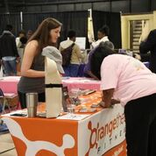
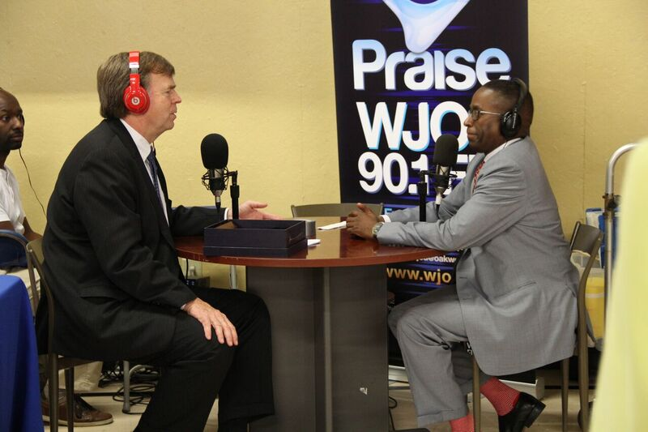

Tier Sponsorship Benefits

Platinum Sponsorship ($1,000)
Company logo displayed at venue throughout the day of the event
Company logo with link on homepage of WJOU website
 One (1) premium table location
 Two (2) Box Lunches
 Special recognition day of the event
 25 (thirty-second) Underwriting spots to air by December 31, 2017

Gold Sponsorship ($500)
 Company logo displayed at venue throughout the day of the event
 Company logo with link on homepage of WJOU website
 Banner display
 One (1) premium table location
 Two (2) Box Lunches

Silver Sponsorship ($150)
 Company logo displayed at venue throughout the day of the event
 Company logo with link on homepage of WJOU website
 One (1) table location
 Two (2) Box Lunches

